**Document Control**

**Document Information**

|  |  |
| --- | --- |
| **©** | **Information** |
| Document Id | *1* |
| Document Owner | *BC_TEAM_6* |
| Issue Date | *27/03/2021* |
| Last Saved Date | *27/03/2021* |
| File Name | *BC_Team_6_Project_Plan* |

**Document History**

|  |  |  |
| --- | --- | --- |
| **Version** | **Issue Date** | **Changes** |
| *[1.0]* | *27/03/2021* | *Added Planning Basis, Project Plan and Appendix* |
|  |  |  |
|  |  |  |
|  |  |  |

**Table of Contents**

**1** **Planning Basis 2**

1.1 Scope 2

1.2 Milestones 2

1.3 Phases 2

1.4 Activities 3

1.5 Tasks 3

1.6 Effort 3

**2** **Project Plan 4**

2.1 Schedule 4

2.2 Project Team 5

2.3 Assumptions 5

2.4 Constraints 5

**3** **Appendix 5**

# 

# **Planning Basis**

## **Scope**

The scope of the project is to build a Buyer-Seller Market Application for Books using Blockchain Technology with functionalities including browsing, buying, selling, reselling books among account holders.

## **Milestones**

|  |  |  |
| --- | --- | --- |
| **Milestone** | **Description** | **Delivery Date** |
| Project Team appointed. | The team for the project has been appointed. | 26/03/21 |
| Requirement Validation. | The given requirements has been validated. | 27/03/21 |
|  |  |  |

## **Phases**

|  |  |  |
| --- | --- | --- |
| **Phase** | **Description** | **Sequence** |
| Project Initiation | Comprehending the Problem statement by going through the given description, functional requirements and Tech Stack. | Phase # 1 |
| Project Planning | Deliverables are requirements are defined and Project Schedule is created. Designs for the user interface are created. | Phase # 2 |
| Project Implementation | Developing the application by writing efficient code following the designs defined in the planning phase. | Phase # 3 |
| Project Testing | Creating Test Cases to verify that the project works accurately and efficiently. | Phase # 4 |
| Project Submission | Submission of the project for further evaluation. | Phase # 5 |

## **Activities**

|  |  |  |
| --- | --- | --- |
| **Phase** | **Activity** | **Description** |
| Project Planning | Develop Quick Plan | Produce a document describing phases and sequence of activities that are to be undertaken. |
| Project Planning | UI Design | Developing wireframes for User Interface |
| Project Implementation | Developing Solidity Files | Developing the code to operate on Blockchains in Ethereum Network. |
| Project Implementation | Developing the User Interface and integration | Developing a responsive user interface using ReactJS and integrating it with the front-end. |
| Project Testing | Developing Test cases | Developing appropriate test cases to verify that the application works accurately and modify the code to clear bugs if any. |
| Project Submission | Submission | Closing all the issues and submitting the project. |

## **Tasks**

|  |  |  |  |
| --- | --- | --- | --- |
| **Phase** | **Activity** | **Task** | **Sequence** |
| Project Planning | Develop Quick Plan,  UI Design | Identify the Requirements  Document Quick Plan  Assigning roles to teammates  Develop the wireframes for the webpages to be created | 1st  2nd  3rd  4th |
| Project Implementation | Develop solidity files and UI. | Develop the Solidity files to fulfill the functional requirements  Develop UI from wireframes | 1st  2nd |
| Project Implementation | Integrate Frontend and Backend | Integration of Frontend and Backend. | 1st |
| Project Testing | Create Test cases | Create test cases to find bugs and flow of the application.  Clear bugs if any. | 1st  2nd |
| Project Submission | Submit | Close all issues if any open  Submit the Project | 1st  2nd |

## **Effort**

|  |  |
| --- | --- |
| **Task** | **Effort** |
| Identify Requirements  Document Quick Plan  Assign Roles  Develop Wireframes | *4 hrs*  *5 hrs*  *1 hr*  *4 hrs* |
| Develop Solidity Files  Develop User Interface | *2 days*  *2 days* |
| Integration | *1 day* |
| Testing | *1 day* |

## 

# **Project Plan**

## **Schedule**

Provide a summarized schedule for each of the phases and activities within the project.

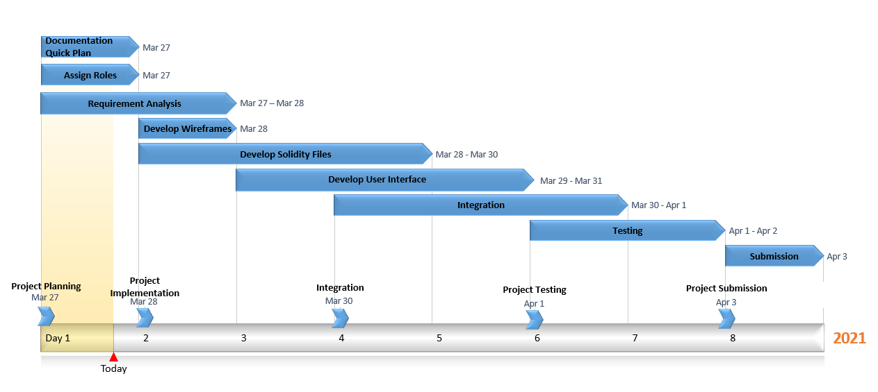

## **Project Team**

|  |  |
| --- | --- |
| **Role** | **Name** |
| Front-end Developer | Manish Nandineni |
| Full Stack Developer | Sameer Kasivajhula |
| Backend Developer | Sai Manikanta |
| Backend Developer | Manasa Raghavaraju |

## **Assumptions**

It is assumed that:

* The project will not change in scope
* The tech stack will not change=

## **Constraints**

* The project team must deliver the application before 3rd April 2021

# 

# **Appendix**

Attach any documentation you believe is relevant to the Project Plan. For example:

* Detailed Project Schedule (listing all project phases, activities and tasks)
* Other documentation (Business Case, Feasibility Study, Project Charter)
* Other relevant information or correspondence.